* Def. A **Normal distribution** is described by a **__________________________________________________** density curve called a ________________________________________.
* Any Normal distribution is completely specified by two numbers: ­­­­­­_______________________________
* All Normal distributions have _________________________________________________. Any differences can be explained by_________________________.
* X follows the normal distribution with __________ and ____________ ⬄ X~_______________

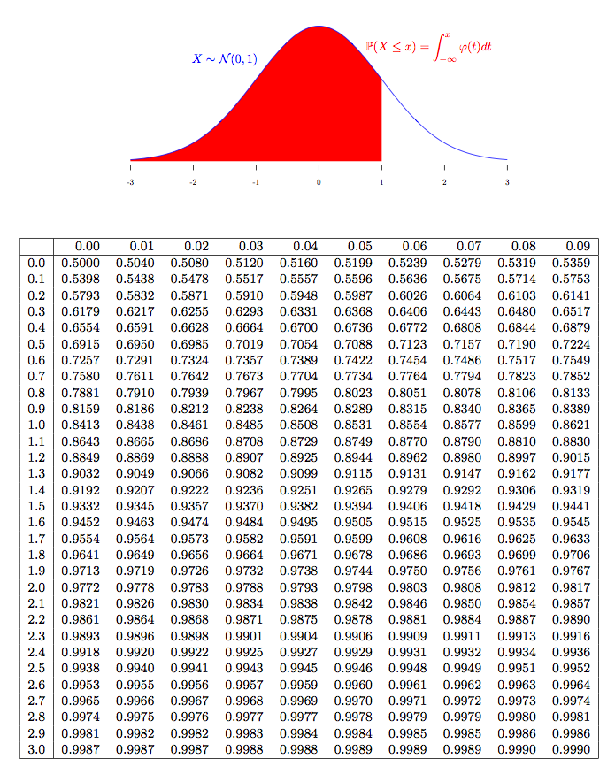**Table Standard Normal Probabilities**

$$P\left(X≤1.33\right)=0.9082$$

$P\left(X≤1.33\right)=$

* **___________________________**
* **P(-1.76<Z<0.58) = __________________________**
* Def. The **standard** normal distribution is the normal distribution with _______________________________
* Def. Z-value: Z=______________________________

If X~N($μ,σ^{2}$), Z~_____________________________

* **Practice:**

Studies on automobile safety suggest that stopping distances follow an approximately Normal distribution. For one model of car traveling at 62 mph, the mean stopping distance is μ=155 ft with a standard deviation of σ=3 ft . Danielle is driving one of these cars at 62 mph when she spots a wreck 160 feet in front of her and needs to make an emergency stop. About what percent of cars of this model when going 62 mph would be able to make an emergency stop in less than 160 feet? Is Danielle likely to stop safely?

* **The 68–95–99.7 RULE**

**In a Normal distribution with mean $μ$**  and standard deviation $σ$:

**Approximately _________ of the ___________________________ fall within __________ of _____________________**

**Approximately _________ of the ___________________________ fall within __________ of _____________________**

**Approximately _________ of the ___________________________ fall within __________ of _____________________**